***MARKETING MANAGEMENT***

*Submitted to the*

**SAVEETHA INSTITUTE OF MEDICAL AND TECHNICAL SCIENCES**

In partial fulfillment for the completion of the

**Project**

**by**

Bommisetty Eswar raj - 192111257 (CSE)

Chemarthi Radhika - 192111223 (CSE)

**Under the guidance of**

**K. Vijaya Bhaskar**

**Assistant Professor**



**INSTITUTE of SCience and HUMANITIES**

**SAVEETHA SCHOOL OF ENGINEERING**

**CHENNAI – 602 105**

**TAMILNADU, INDIA**

**September 2022**

**BONAFIDE CERTIFICATE**

This is to certify that the project report entitled **“marketing management”** submitted by “Bommisetty Eswar raj - 192111257(CSE), Chemarthi Radhika-192111223(CSE), to Saveetha School of Engineering, Saveetha Institute of Medical and Technical Sciences, Chennai, is a record of bonafide work carried out by him/her under my guidance. The project fulfills the requirements as per the regulations of this institution and in my appraisal meets the required standards for submission.

|  |  |
| --- | --- |
| **K. Vijaya Bhaskar**  Supervisor,  Department of programming,  Saveetha School of Engineering,  SIMATS, Chennai – 602 105. |  |

**Internal examiner External Examiner**

**ACKNOWLEDGEMENT**

I take immense pleasure in expressing my gratitude to our Honourable Chancellor **Dr. N. M. Veeraiyan** for being our constant source of inspiration.

I sincerely thank our Vice-Chancellor, **Prof. Dr. Rakesh Kumar Sharma** for providing the academic ambience to complete the project successfully.

With profound gratitude, respect and pride, I express my sincere thanks to our Director, **Mrs. Ramya Deepak**, whose enthusiasm and dynamism being the driving force behind all our accomplishments.

I take this opportunity to extend our heartiest thanks to our beloved Principal, **Dr.B. Ramesh** for providing us excellent facilities and unstinting support which were the sustaining factors in carrying out the work successfully.

It is a genuine pleasure to express my deep sense of thanks and gratitude to my mentor and my project guidance  **K. Vijaya Bhaskar**, Department of Science and Humanities. His timely advice, meticulous scrutiny and scientific approach have helped me to a very great extent to accomplish this task and also his dedication and keen interest had been solely and mainly responsible for completing my work.

Last, but not least, a very special thanks to my parents and friends for their moral support and care extended during the demanding times.

|  |  |  |  |
| --- | --- | --- | --- |
| **S.No** | **CONTENTS** | | **Page No** |
| 1 | Abstract | | 5 |
| 2 | Introduction | | 6-7 |
| 3 | Objectives | | 5 |
| 4 | Literature Review | | 8-9 |
| 5 | Suggestions | | 9 |
| 6 | Data Analysis | | 10-15 |
| 7 | Conclusion | | 17 |
| 8 | References | | 17-18 |
|  | |
|  | |
|  | |
|  | |

***Marketing management***

**ABSTRACT:**

This paper presents a framework or set of ideas for using customer satisfaction principles and strategies to improve the quality responsiveness and possibility of public sector privately provided services in valuable communities. Marketing management performs the task of converting thepotential customers into actual customer. This is possible through satisfaction of customer's needs and wants by delivering them, appropriate goods and services according to their needs and wants, at right time and through convenient channel. Based on a systematic assessment of more than 25 years of Marketing management research, the authors review the major themes discussed in the literature, identify and resolve inconsistencies and definitional ambiguities, and develop a comprehensive conceptual model that integrates and synthesizes the current body of knowledge about marketing management.

**OBJECTIVES:**

* To study the concept of customer satisfaction in general.
* To study the brand awareness of products.
* To identify the level of customer satisfaction towards the price and package of the product.
* To analyse the customer preference towards the product.
* Development and Expansion of a Product of the Market.
* Appropriate Distribution Management.
* Increase Profits by Reducing Costs.
* Achievement Customer Satisfaction.

**INTRODUCTION:**

Customer’s satisfaction can be considered as one of the key indicator of company’s future profits. The development of the customer’s satisfaction theory has led to the emergence of two perspectives.

* The study of customer satisfaction through product performance became more important.
* In general, satisfaction is a person’s feelings of pleasure or disappointment resulting from comparing products perceived performance relation to his/ her expectations.
* If the performance matches the expectations, the customer is satisfied.
* Customer satisfaction is a part of customer’s experience that exposes a supplier’s behaviour on customer’s expectation and how promptly services are provided.
* This satisfaction could be related to various business aspects like marketing.
* Quality of products and services, responses customer’s problems and queries, completion of project and post delivery services.
* Marketing Management performs all managerial functions in the field of marketing.
* Marketing Management identifies market opportunities and comes out with appropriate strategies for exploring those opportunities profitably.
* Traditionally, markets were viewed as a place for exchange of goods and services between sellers and buyers to the mutual benefit of both.
* Today, marketing is exchange of values between the seller and the buyer. Value implies worth related to the goods and services being exchanged.
* The buyer will be ready to pay for the goods if they have some value for him.

**Problem identification:**

* Recruiting talent.
* Maintaining a sufficient budget.
* Generating leads.
* Finding the right tools.
* Being risk-averse.
* Moving into new markets.
* Retaining customers.

**Advantages:**

* Marketing Increases the National Income.
* Marketing Helps in Optimal Utilization of Resources.
* Marketing Facilitates Exchanges in the Ownership and Possession of Goods and Services.
* Marketing Raises the Standard of Living.
* Marketing Provides Employment Opportunities.
* Marketing Stabilizes the Economic Conditions.
* It strengthens your brand.

**Disadvantages:**

* Marketing can be expensive and drain profits, especially for smaller businesses.
* It's difficult to accurately assess the cost benefit of a marketing campaign.
* Not all campaigns are successful because they were not carefully researched and planned.
* The business may require additional staff to assist with advertising.
* The cost of branded items used for advertising reduces profit margins.
* Ignores societal and environmental good.
* Suppresses innovation.

**Literature reviews:**

[Peterson etal, 2015](https://www.sciencedirect.com/science/article/pii/S0019850122000256#bb0265): (JS)

* Journal of Selling, 15 (1) (2015), pp. 29-43.

An ineffective marketing management decreases a firm's performance through salespeople rejecting qualified leads, below average conversion rates within the sales funnel, and poor efforts to generate demand, capture revenue, and gain a competitive advantage.

[Johnson & Boeing, 2016](https://www.sciencedirect.com/science/article/pii/S0019850122000256#bb0350):(JPSSM)

* Journal of Personal Selling & Sales

Management, 36 (2) (2016), pp. 190-205.

It have been suggested in the marketing management literature as relevant factors that impact marketing management functioning.

They were expected to result in interesting insights into how the marketing management research domain evolved.

[Hult, Morgeson, Morgan, Mithas, & Fornell, 2017](https://www.sciencedirect.com/science/article/pii/S0019850122000256" \l "bb0330):(JAMS)

* Journal of the Academy of Marketing Science, 45 (1) (2017), pp. 37-54

To this effect, a firm's marketing and sales departments must collaborate to understand customers , and develop and implement effective marketing strategies. So the firm is able to deliver superior value to customers.

[Palmatier, Houston, & Hulland, 2018](https://www.sciencedirect.com/science/article/pii/S0019850122000256#bb0615):(JAMS)

* Journal of the Academy of Marketing Science, 46 (1) (2018), pp. 1-5

The development in marketing management conceptual model to integrate and synthesize extant knowledge, highlight gaps in the body of extant research, and suggest avenues for future research that may help fill these gaps.

[Gonzalez & Claro, 2019](https://www.sciencedirect.com/science/article/pii/S0019850122000256#bb0200):(JAMS)

* Journal of the Academy of Marketing Science, 47 (5) (2019), pp. 795-814

 The daily interactions with customers, salespeople may collect market intelligence, share it with marketing, participate in development of marketing strategy and implement the strategy in the field thereby helping firms deliver superior customer value.

**Methodology of marketing management:**

* The proposed methodology is dependent on the human factor – marketing specialists and their decision-making – which also limits its success.
* The methodology is therefore not an attempt to replace humans, only to provide them with adequate support in decision-making or marketing management.
* A marketing employee should be aware of the various kinds of interactions and synergistic effects which can occur.
* Therefore, it is necessary for the management of marketing activities in this environment to equip the employee with knowledge which they can use as a basis for evaluating data acquired from the environment.
* Within the methodology, it is primarily the properties of complex networks along with a search for key nodes or hubs with greater interaction potential, both across services and within each service.

**Findings:**

* From this marketing management survey, we can find that the maximum qualification is master of business administration

(MBA).

* The minimum qualification is master in management

(MIM), The bachelor of business management is as follows in the pie chart.

* We can find that the maximum / minimum experience is:
* 0-2 years =64%
* 2-4years=28%
* 4-6years=2%
* 6-10years=6%
* We can find the department preferred by the people is :
* Marketing - 54%
* Finance -22%
* Sales -18%
* Advertising -6%
* Suggestion provided by the people during the survey for the plans and strategies for marketing is as follows:
* Situation analysis.
* Decision making.
* such things are meant to be confidential.
* product, price and promotion.
* Develop budget.
* People’s interest in marketing:
* Most of the people are interested in marketing as highest response
* How would you advertise to gain profits:
* By offering some discounts.
* Product promotions.
* In the social media we can develop the profits.
* By hiring good staff.
* Providing some offers like buy 1 get 1 free.
* By reducing the cost.

**Data analysis:**

**Qualification:** In this pie chart representation shows that qualification of different people who participated in this survey.

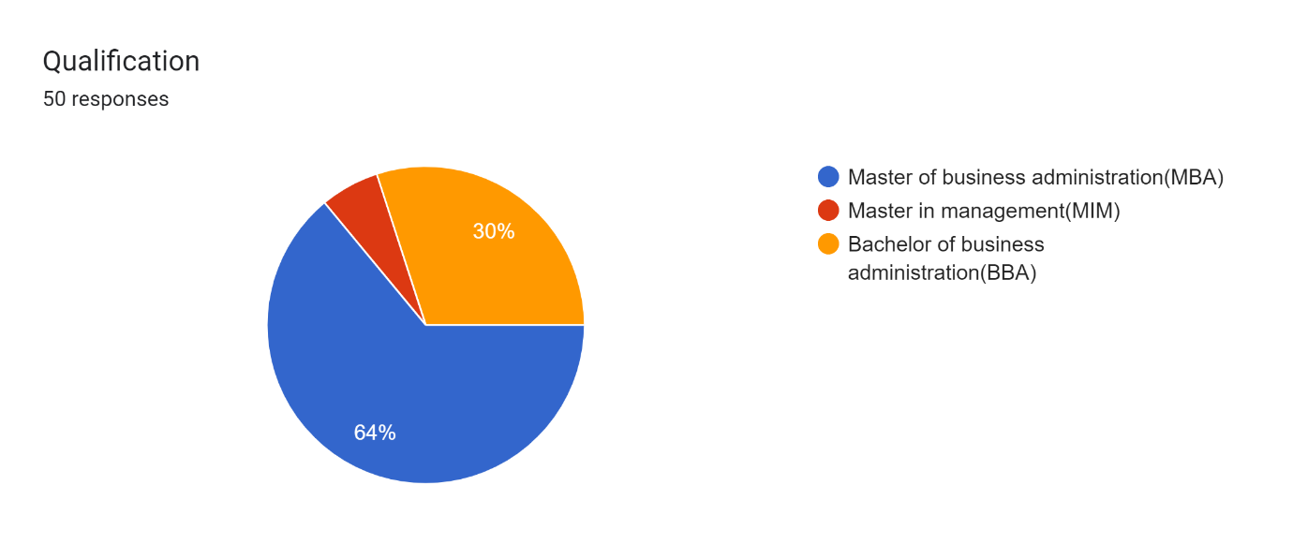

**Experience:** In this pie chart representation shows that experience of different people who participated in this survey.

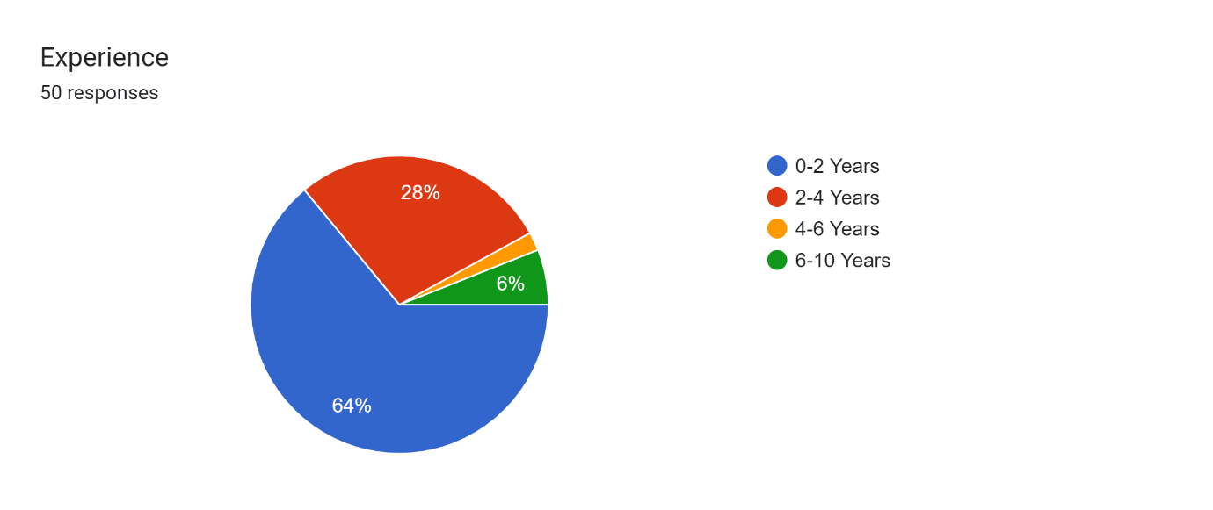

**Department do you prefer:** In this pie chart representation shows that departments which were people preferred who participated in this survey.

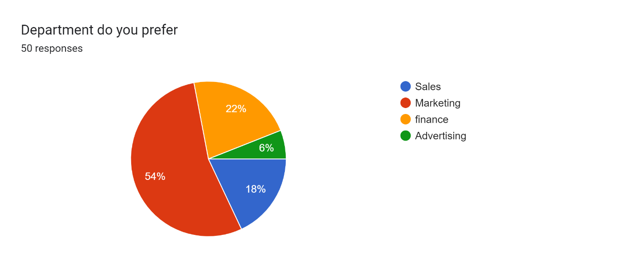

**What are the plans (or) strategies you suggest for marketing:** In this bar graph representation some plans and strategies suggested by the people who participated in this survey.

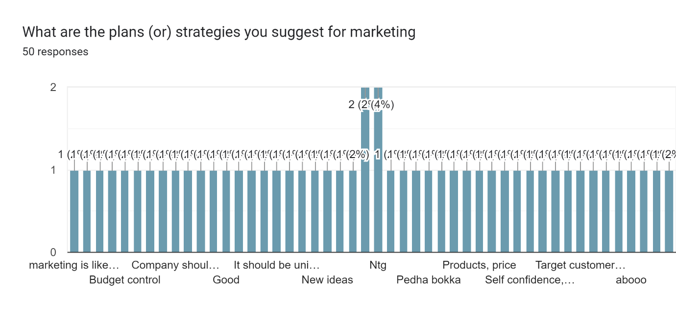

**You’re interested in marketing**: In this pie chart representation shows that people’s interest in marketing who participated in this survey.

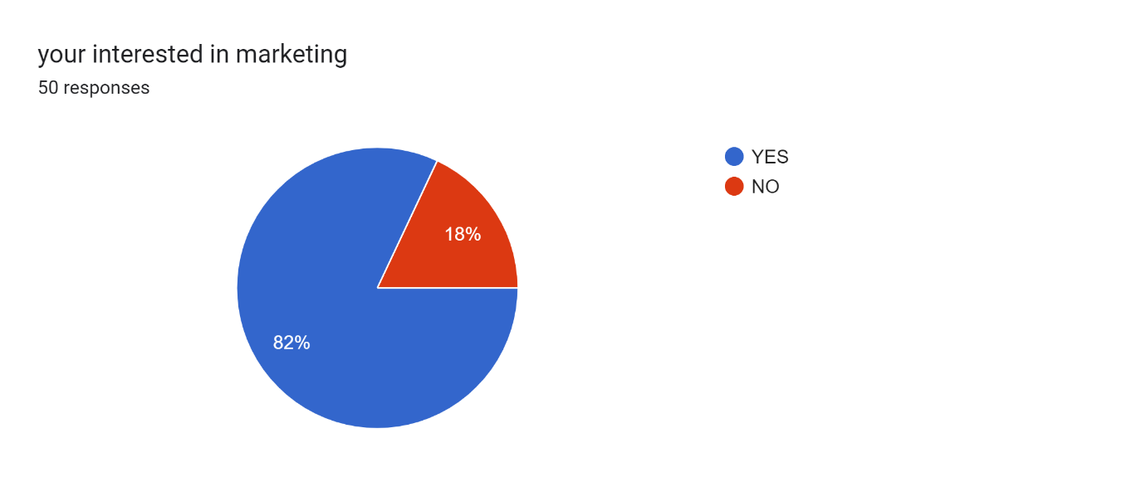

**How would you advertise to gain profits:** In this bar graph representation shows different ways to advertise to gain profit who participated in this survey.

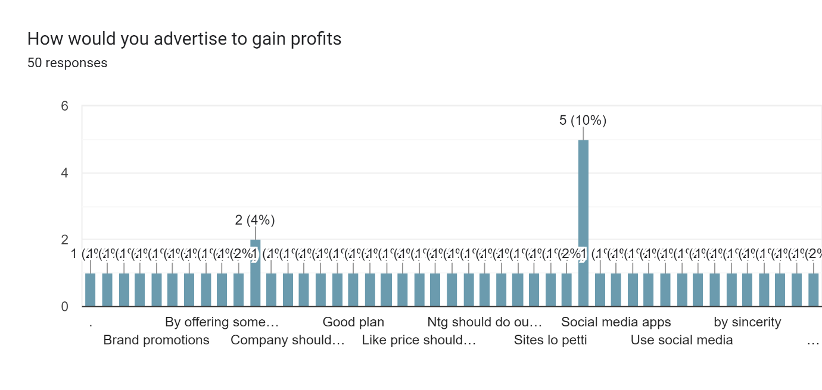

How would you decrease the risk in the marketing: In this bar graph representation shows that some suggestions given by the people to decrease risk in the marketing who participated in this survey.

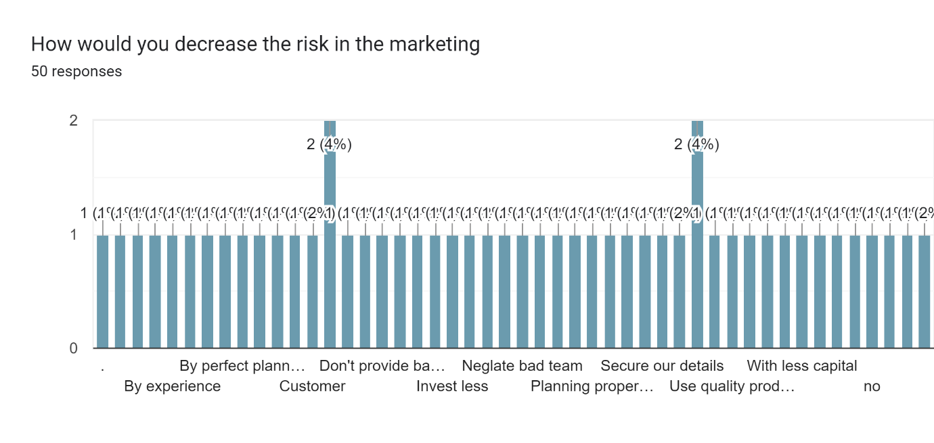

**Would you share your marketing experience:** In this pie chart representation shows that sharing their marketing experience who participated in this survey.

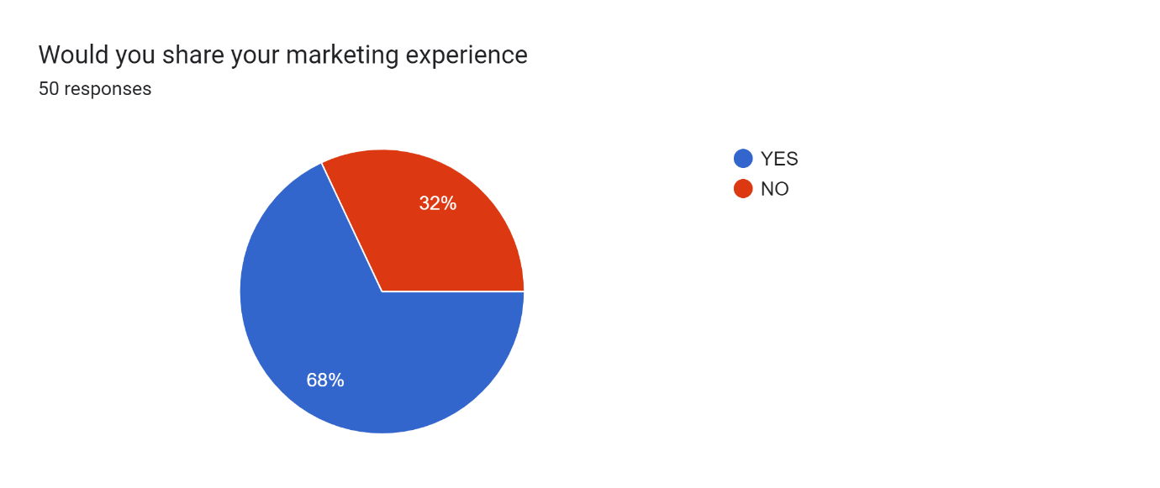

Manager name: In this pie chart representation shows that manager names in a following company selected by different people who participated in this survey.

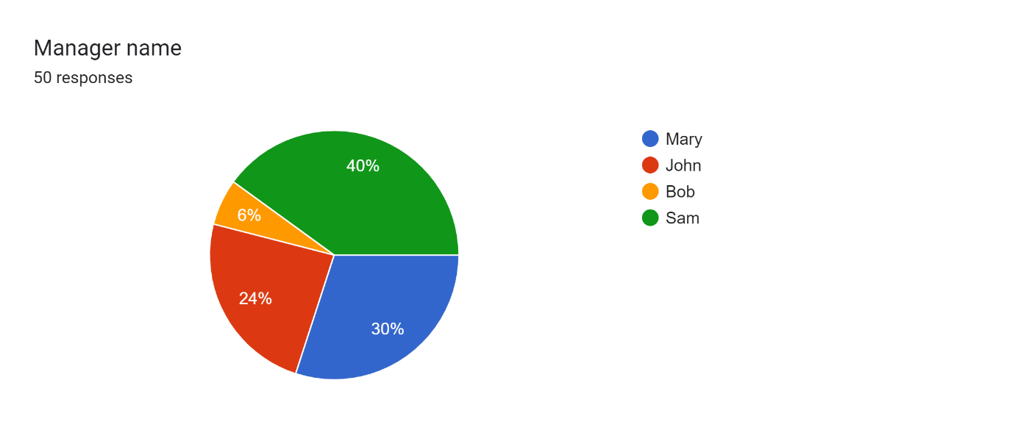

**Did you perform any projects in company:** In this pie chart representation shows that did they perform any project (or) not in a company of different people who participated in this survey.

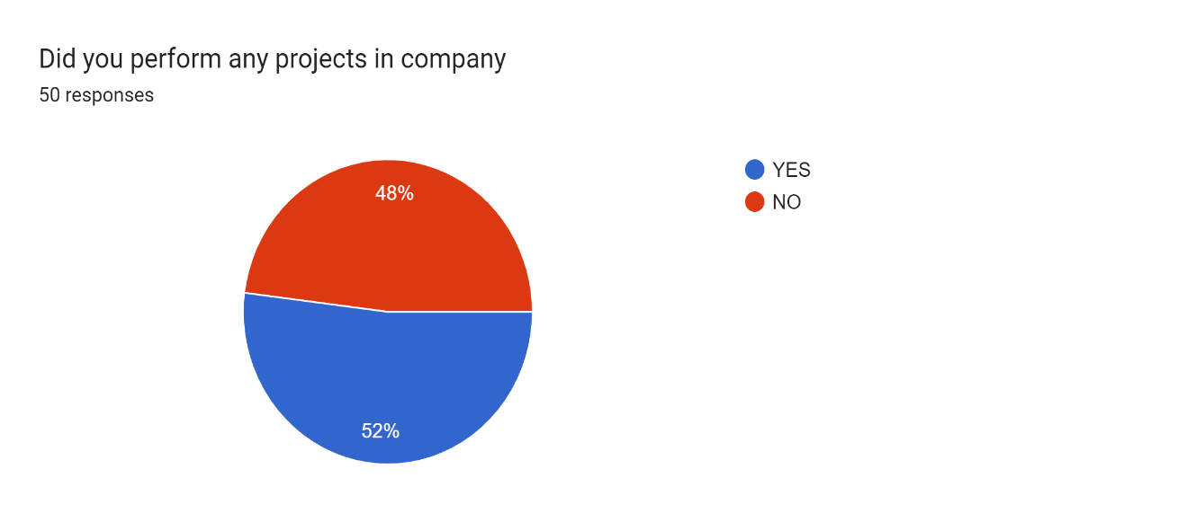

**Future enhancement:**

Our systematic literature review not only serves to examine and synthesize the current body of work on marketing management, but also provides a foundation to derive future research directions. suggests three major changes occurring in the world of sales and marketing:

* a rapidly changing technological environment including big data's impact on sales and marketing practice.
* the emergence of developing markets as strong players in a globalized world.
* the changing roles of marketing and sales in increasingly competitive business environments.

Our systematic literature review, we identify four directions for future research that will have a major impact on our understanding of the functioning and nature of marketing management.

* the impact of digital technologies on marketing management.
* the impact of national culture on marketing management.
* the impact of the evolving roles of sales and marketing management.

**Discussion:**

* The value of a systematic literature review is to “carefully identify and synthesize relevant literature to evaluate a substantive domain and thereby provide readers with a state-of-the-art understanding of the research topic”.
* Based on what they consider the key benefits of review papers, we identify four major contributions of our literature review to the marketing management research domain.
* First, we critically evaluated the methodological approaches and theories commonly used by marketing management researchers.
* We showed that marketing management studies tend to be biased toward large companies with established sales and marketing departments in Western countries.
* In addition, less than one third of the marketing management studies specify their theoretical grounding, with a strong emphasis on social identity, exchange, network, and interdependence theory.

**Conclusion:**

* The functioning of a firm's marketing management is a key concern for both marketing scholars and executives.
* Over 30 years, research in this domain has generated many useful insights about the nature and importance of marketing management.
* At the same time, the marketing management literature lacks a clear, commonly accepted definition of the marketing management and a synthesis of our current understanding of marketing management.
* In this article we define the scope of the marketing management, integrate and synthesize the extant marketing management literature, and develop several promising directions for future research.

**Reference:**

[Peterson etal, 2015](https://www.sciencedirect.com/science/article/pii/S0019850122000256#bbb0625)

When sales and marketing align: Impact on performance

Journal of Selling, 15 (1) (2015), pp. 29-43.

[Johnson and Boeing, 2016](https://www.sciencedirect.com/science/article/pii/S0019850122000256#bbb0350)

A união faz a força (there is strength in unity): Understanding the sales-marketing interface in Brazil

Journal of Personal Selling & Sales Management, 36 (2) (2016), pp. 190-205.

[Hult, Morgeson, Morgan, Mithas and Fornell, 2017](https://www.sciencedirect.com/science/article/pii/S0019850122000256#bbb0330)

Do managers know what their customers think and why?

Journal of the Academy of Marketing Science, 45 (1) (2017), pp. 37-54.

[Palmatier, Houston and Hulland, 2018](https://www.sciencedirect.com/science/article/pii/S0019850122000256#bbb0615)

Review articles: Purpose, process, and structure

Journal of the Academy of Marketing Science, 46 (1) (2018), pp. 1-5.

[Gonzalez and Claro, 2019](https://www.sciencedirect.com/science/article/pii/S0019850122000256#bbb0200)

How intrafirm intermediary salespeople connect sales to marketing and product development

Journal of the Academy of Marketing Science, 47 (5) (2019), pp. 795-814.